COMP08033 Computational Thinking with Algorithms

Algorithms Problem Sheet (Python)

Q1. There are several issues with this code.

Firstly, running this python code will not return any result, as the recursive algorithm is not calling itself (mystery). Also it will not produce an error, the program just terminates with no result.

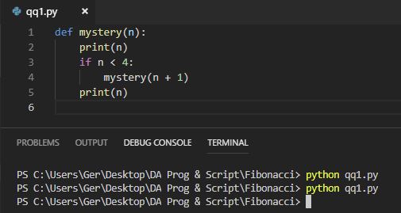

Secondly, the print statement has remained inside the if condition. The code states to print(n) and it should have called mystery(n).

If the code was formatted and the print statement was outside the if statement, the result is 2, as we are telling python to print 2, see below

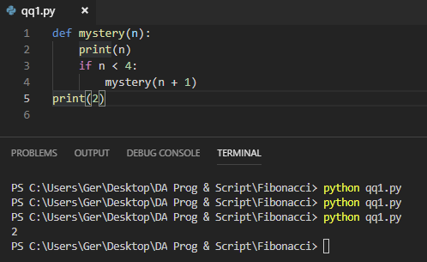

Finally, n has not been defined so the algorithm does not know where to begin the sequence, if the rest of the code had been written and formatted correctly. Below is an example of the output if n had been defined as 2.

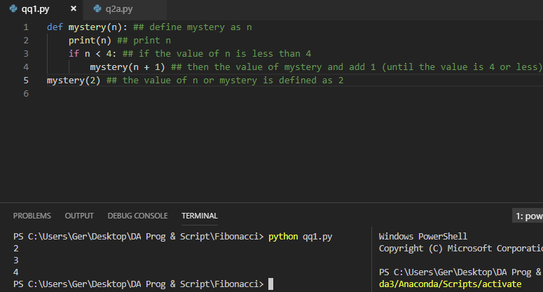

The recursion trace for the call mystery (2)

Call

Return

Mystery (2)

Call

Return

Mystery (3)

Call

Return

Mystery (4)

Q2(A) The result of the call to finder will be 1001 for the range stated.

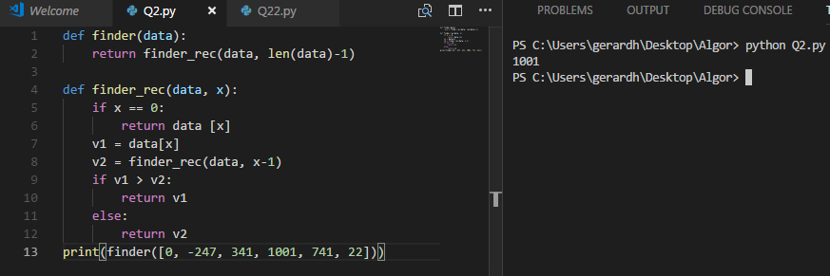

Q2(B) The Finder method is attempting to determine the highest value in the data set.

Q2(C)

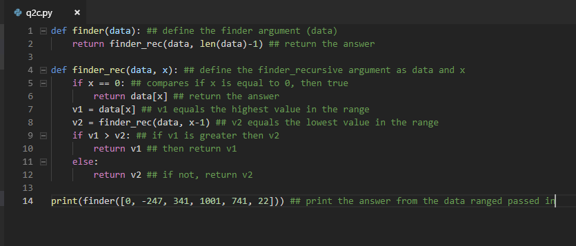

Q2(D)

An iterative version of this function uses a while loop. It involves executing the same block of code over and over. In this function the while loop is executing until it returns the highest value in the sequence of number passed in.

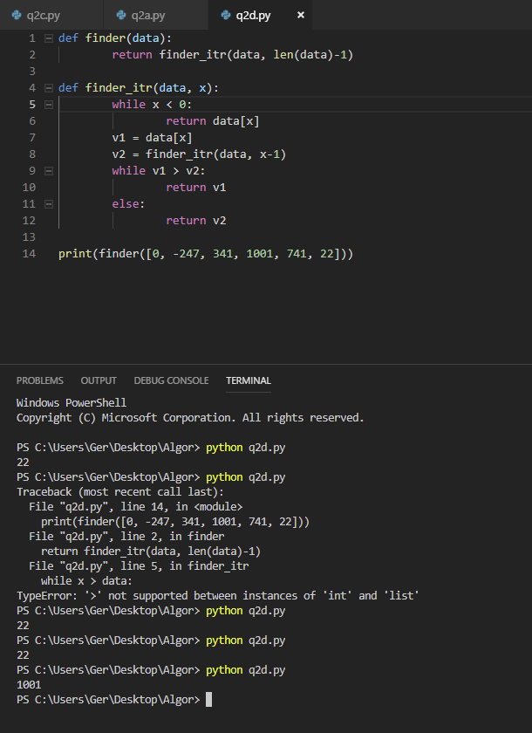

Q3(A) When considering complexity in terms of algorithms it focuses on internal factors, in this case the time required to run the algorithm. We need to consider what is the result on performance as the size of the problem or the input of the dataset gets larger. The characteristics of the dataset will also have an impact on the length of time an algorithm takes to execute. For example, does the dataset contain all positive integers, or a mix of positive and negative, are we comparing words etc, all these factors will need to be considered.

Def of best case time complexity…….